**Building Dynamic Frontend Components For Marketplace- Bandage**

**Brand Name:** Bandage  
**Theme:** A focus on modern, vibrant, and lightweight fashion, emphasizing summer comfort and style.

Day 4 Hackathon Tasks:

**Key Components:**

**Product Listing Component:**

**Source code snippet:**

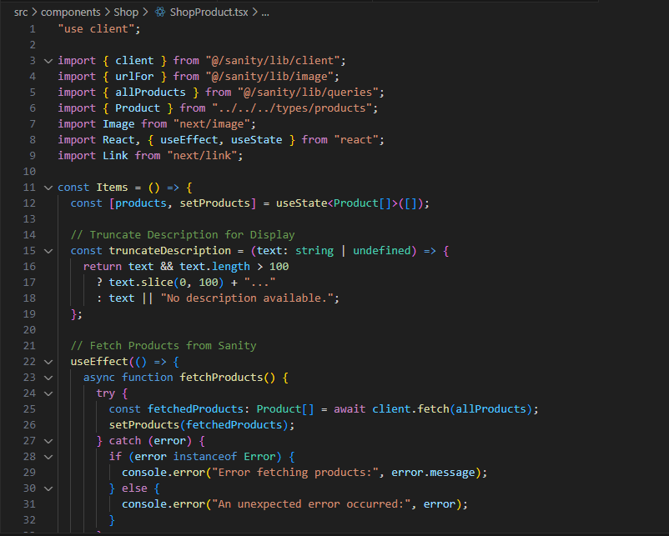

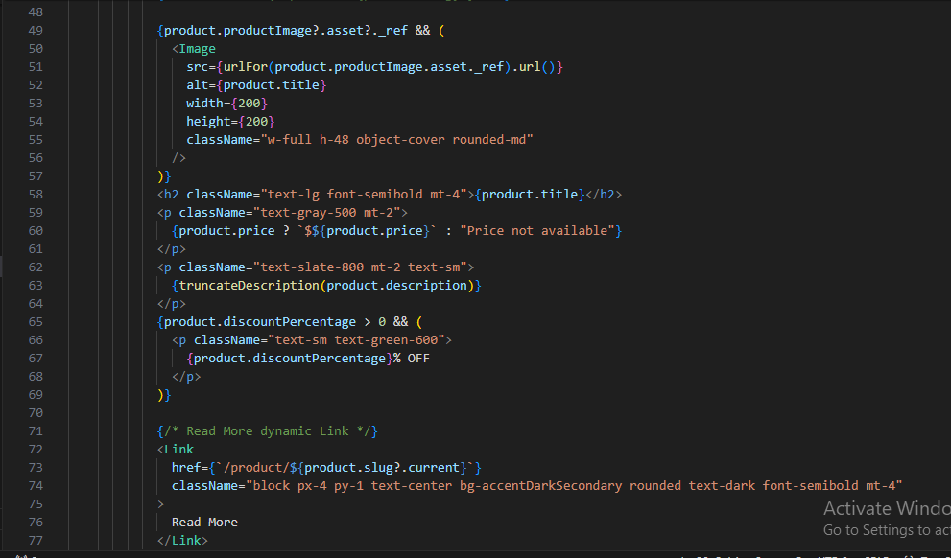

**Output Snippet:**

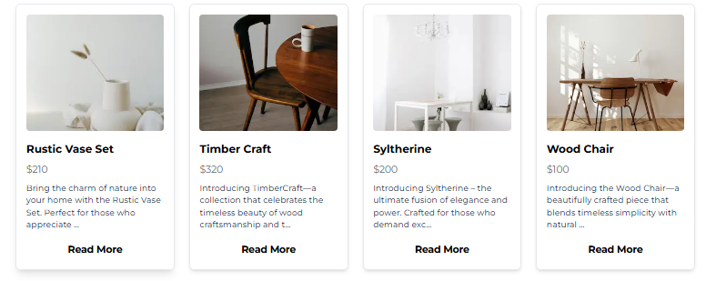

**Product Detail Component:**

**Source code snippet:**

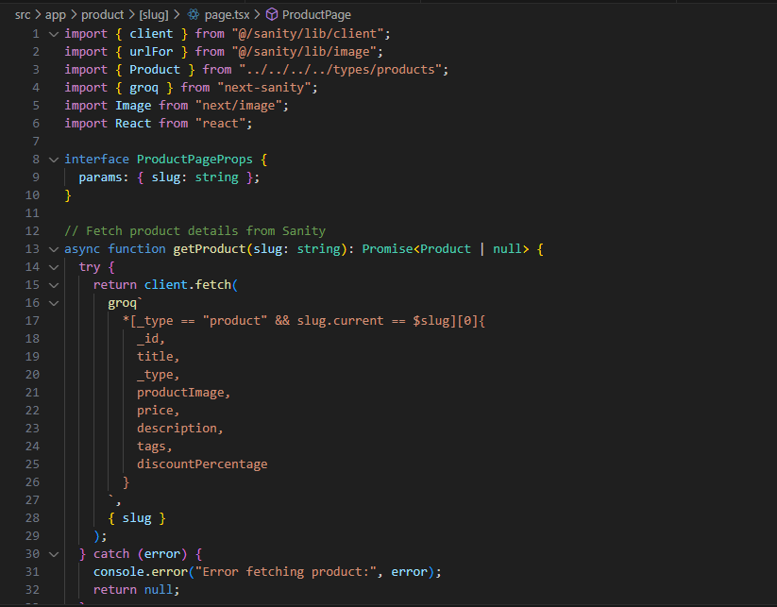

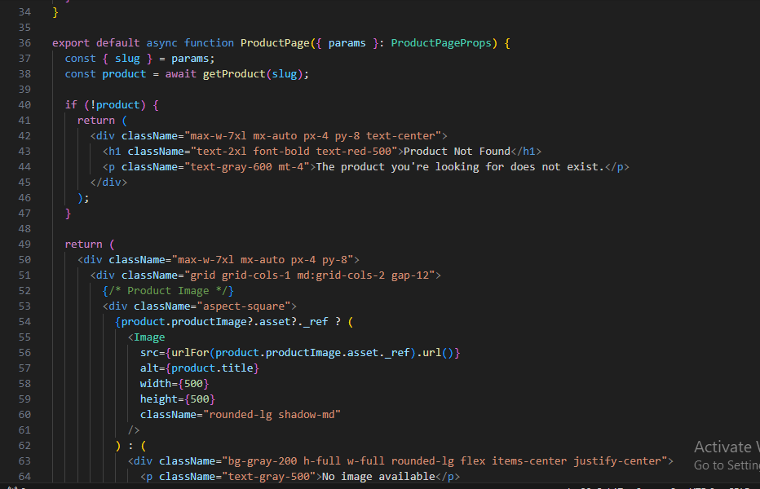

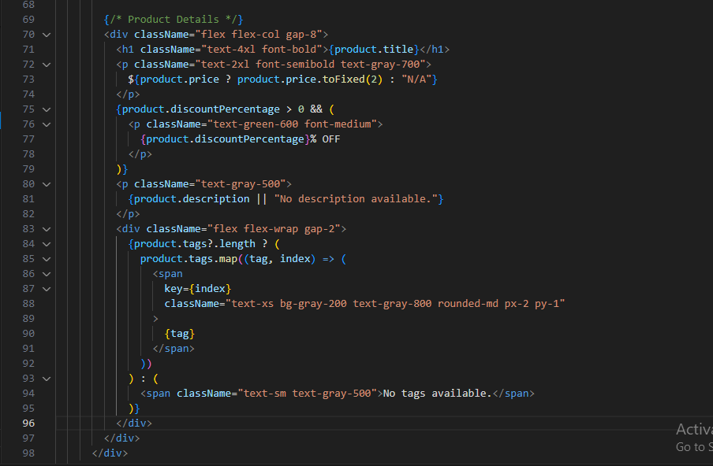

**Output Snippet:**

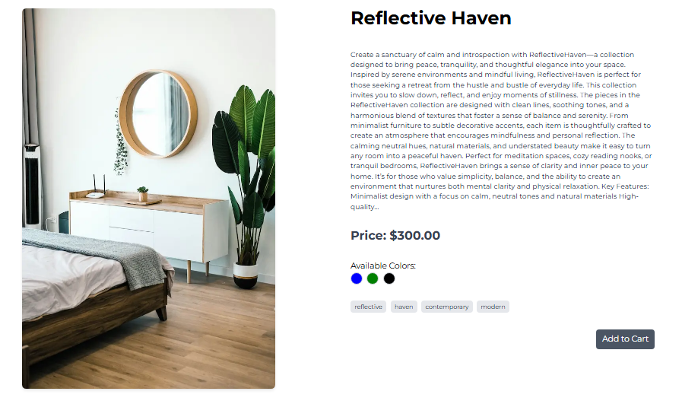

**Category Component:**

**Source code snippet:**

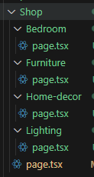

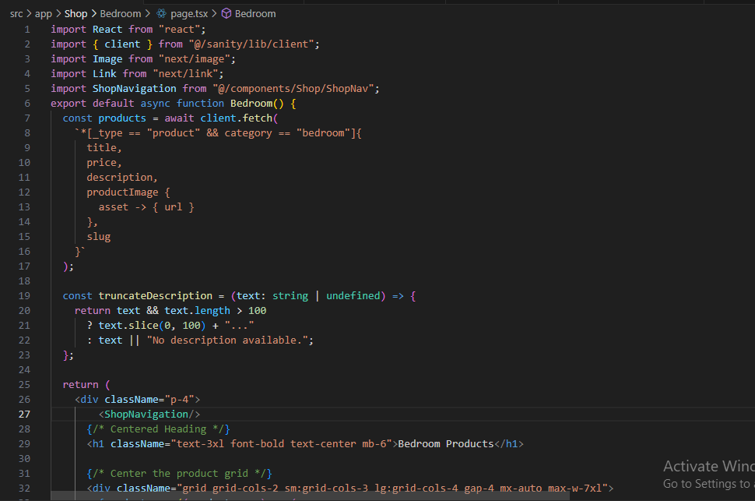

**Output Snippet:**

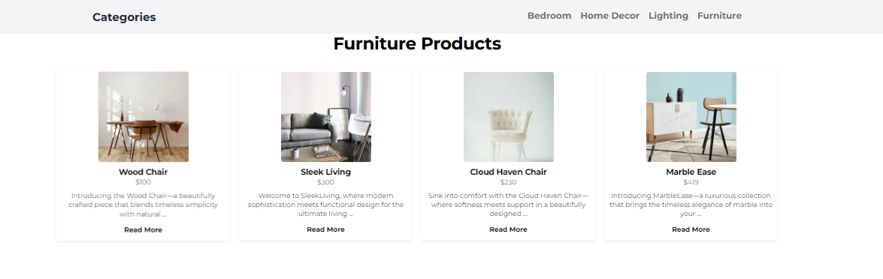

**Search Bar:**

**Source code snippet:**

**Output Snippet:**

**Cart Component:**

**Source code snippet:**

**Output Snippet:**

**Checkout Flow Component:**

**Source code snippet:**

**Output Snippet:**

**Filter Panel Component:**

**Source code snippet:**

**Output Snippet:**

**Footer and Header Components:**

**Source code snippet:**

Footer:

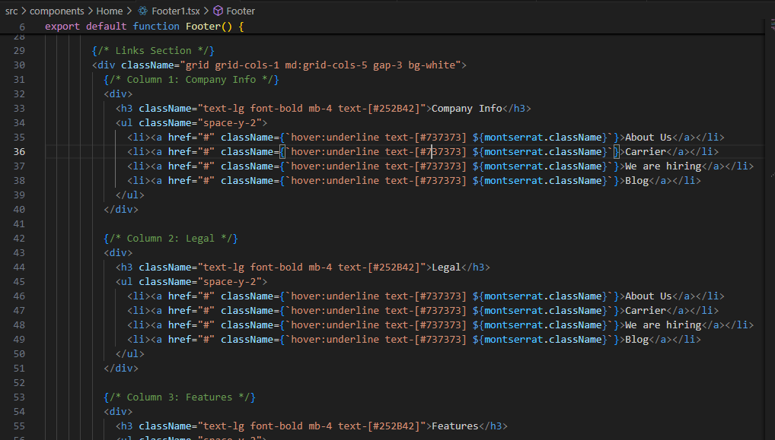

**Output Snippet:**

Footer:

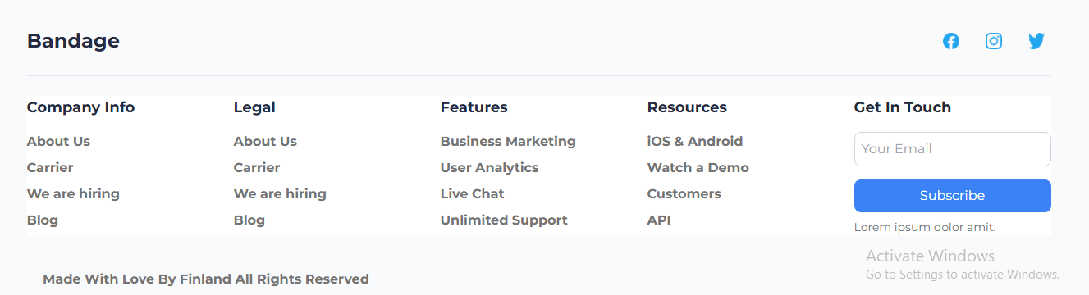

**FAQ and Help Center Component:**

**Source code snippet:**

**Output Snippet:**

**Social Media Sharing Component:**

**Source code snippet:**

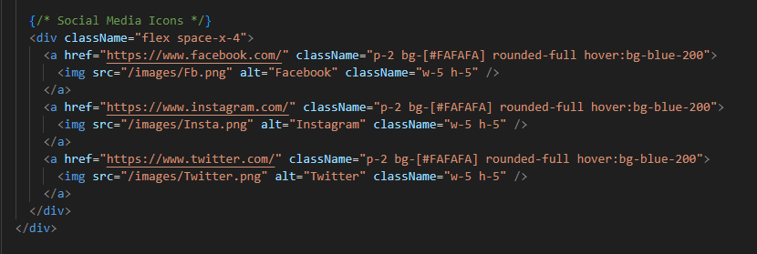

**Output Snippet:**



**API Integration:**

1. **Sanity API Fetching Process**: As you are utilizing Sanity CMS, make sure the data fetching is handled appropriately. • **Sanity Client Configuration (if not already implemented)**: Set up the Sanity client in your lib folder for API integration.

**Dynamic Routing**

Dynamic routing is employed to manage routes such as **/Product/[slug]** for individual product pages.

1. **Create a Dynamic Route File**:  
   Inside the app directory, create a [slug] folder then page.tsx file within the product folder:



1. **Get Product Data Dynamically:**

**Final Check List:**

|  |  |  |  |  |
| --- | --- | --- | --- | --- |
| Frontend Component Development | Styling and Responsiveness | Code Quality | Documentation and Submission | Final Review |
|  |  |  |  |  |